Work Package 2- GIS- No Integration
GIS- Spatial Viewer- Measure Tool
GIS- Spatial Viewer- Layer Manager
GIS- Spatial Viewer- Map Legend
GIS- Spatial Viewer- Identify Tool
GIS- Spatial Viewer- Map Navigation Tools
GIS- Spatial Viewer- Parametrised Viewer

Map Navigation Tools – Business Rules
- The Map Navigation Tools will have the following functions.
- Zoom to Previous
  - Zoom to Previous always active even in first time load because default map extent is the world boundary envelope and the we need to zoom to the country boundary.
  - Clicking on Zoom to Previous will then re-zoom the map window such that it zooms to the previous map extent.
  - 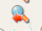
- Zoom to Next
  - Is only active once a user has already performed a “Zoom to Previous” operation in the viewer.
  - Clicking on Zoom to Next will then re-zoom the map window such that it zooms to the next map extent
  - 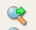
- Zoom to Full extent
  - A user will click on Zoom to full extent to have the map zoom to its full viewing area (in this case it should be the full spatial extent of South Africa).
  - 

- Zoom Using Bounding Box
  - A user will click the shift key on the keyboard and draw a bounding box by keeping the left mouse button held down until they have completed the drawing
  - The four vertices of the drawn rectangle will be used to resize and re-render the map, such that the map will now be zoomed in to the level of the drawn rectangle
  - When the zoom to bounding box tool is used, the longer edge of the drawn rectangle will be used to compute the new map view/ map extent
  - Shift+ mouse move
- Zoom by Mouse Scroll
  - A user will be able to zoom in and out of the map by scrolling their mouse (using either the mouse wheel or similar).
  - Each scroll of the mouse will typically result in a change of a single fixed zoom level
  - Scroll mouse
- Fixed Zoom
  - Fixed zoom refers to the fixed zoom levels as per the published map in GeoServer
  - Each fixed zoom clicks (+ or -) will either zoom the map in or out by a single zoom level respectively
  - 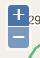
- Zoom to Coordinates
  - A user will enter a set of geographical co-ordinates (Single y,x point, Lat Long, or D.ddd) into the co-ordinate text boxes which appear when activating the Zoom to co-ordinates tool)
  - The map window will then re-center and re-render based on the center point of the map now being the co-ordinates specified by the user
  - A user will enter the desired coordinates they wish to zoom to. The Zoom to coordinates tool will also contain an editable text box which shows the current scale of the map. The user will be allowed to modify or change this scale, such that the map will re-center based on the user-input co-ordinates, at the scale specified by the user
  - 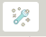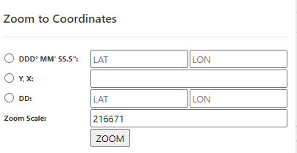
  - 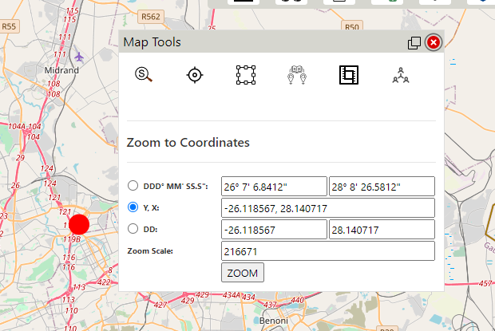
- Zoom to Scale
  - A user will enter a specified scale into the text box which will appear when activating the Zoom to Scale tool
  - The map viewer will then re-render and display at the user specified scale
  - The centre of the map will remain as it was prior to the zoom to scale operation
  - 
  - 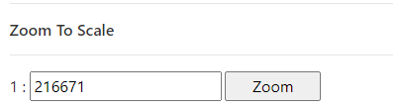
- Pan Tool
  - A user will use the pan tool to navigate and move the map either left, right, up, or down (West, East, North, South)
  - The scale or zoom level of the map will not change during this operation
- The User will be able to increment/decrement a fixed zoom level by operating +/- buttons.

Identify Tool Business Rules
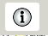

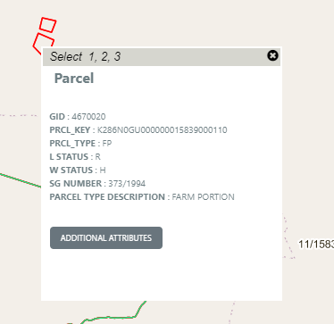
- The identify function can be described as a tool to select a feature/features and retrieve all the associated attribute information of the identified feature(s). It displays the information in a table that appears once the user clicks on a feature on the map using the identify tool.
- In a case where the tool selects multiple features/layers, the information can be seen by selecting the feature number (Select 1,2, 3...).
- The Identify Tool will have the following:
- Standard Identify Function
- Get More Attributes Function (envisaged attributes)
- Attribute Table related to the identify function
- Attribute data related to the attribute table
- Primarily, a few attributes such as LPI Key, Parcel Type Description are displayed, (the comprehensive list is being finalised).
- There will be a button to get “Additional Attributes” from the alpha data.
- The set of additional attributes for the identified record will be returned from a web service which will query the alpha data, utilizing the LPI Key as the primary query indicator.
- It is anticipated that a series of queries or a view will need to be executed on the alpha database, searching for information corresponding to the respective LPI Key across various tables. As per current known requirements, the additional attributes to be fetched via the web service will be:
      - Sectional Titles
      - Servitudes
      - Lease
      - Survey records
      - Subdivision Diagram
      - Consolidation Diagram
      - Substitution Diagram
      - Sect/Art 16 Diagram
      - General Plan
      - Sub divisional General Plan
      - Curvilinear Boundary Diagram
      - Beacon Agreement
      - Servitude Plans
      - Proclamation Diagram
      - Mining Diagram
      - International Boundary Diagram
      - Dummy Diagram
      - Compilation Sheet
      - Correspondence File
      - Farm Comp
      - Miscellaneous Plan
- There will be a link to download the image for each record (where available).
- There will be multiple links to Images of records linked to a parcel or Servitude. It must be noted that there is a one to many relationships between a parcel/spatial object and images.

The insert below depicts the typical Identify Tool with a Table showing the attributes

Layer Manager Tool Business Rules

- Layer Manager lists all the layers that are available to view.
- User can switch on/off the layers as required.
- Two or more layers can be grouped together thereby allowing the user to switch on/off all the layers within the group with a single check.
- Only the administrator can do the configuration of these layers/groups.
- By default, certain layers are switched on.
- Dynamically switching on a layer at a pre-defined scale is also achieved through the configuration changes on the GeoServer by the administrator.

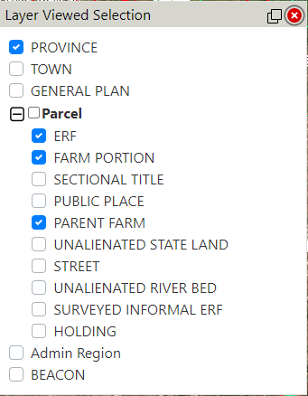

Measure Tool Business Rules

Development of a Measure Tool will take into consideration the following functionalities.
- The measure tools allow the users to calculate:
  - distances,

  - areas,
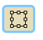
  - perimeters.

- A User can click on the tool and select either area or distance.
- The line and area measurement tools provide segment information as well as total length and area information.
- The measure results are displayed on the screen.
- It may be noted that the accuracy of the results is limited by the National Control Survey System (WGS84 Coordinate system) and the accuracy of the spatial data.

Map Legend Tool Business Rules
- Development of a Map Legend Tool
- Map legend displays the symbols that represent various features on the map.
- These symbols are patches (examples) of the features along with the feature name. E.g., A small red rectangle with a text: Provincial Boundary. This represents the provincial boundary on the map. These symbols are for all feature types i.e. Polygons, Lines and Points.
- 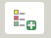
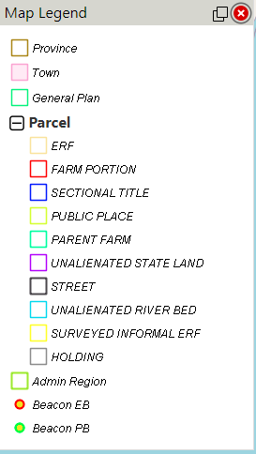

GIS- Spatial Viewer- Parametrised Viewer

http://dwapps.co.za/drdlrrm/csg/search.html

http://dwapps.co.za/drdlrrm/csg/InfoMap.html?Q=K223N0FT000000013026000000&S=FarmName

http://dwapps.co.za/DRDLRRM/CSG/infomap.html?lpi=C00900000000026000002

